**Compiler Construction**

**Phase: 2**

**Project Name: Mini C Language**

**Name: Muhammad Bilal**

**ID: F2018266166**

**Section: V1**

**Note: for NULL Production I’m using symbol ^**

**6) LL(1 )Grammar:**

Cprogram--> void main(){stmtset}

stmtset-->stmt;stmtset'

stmtset'-->stmtset|^

stmt-->decStmt|As|coutStmt|cinStmt

decstmt-->Type idSet

Type--> int

idSet-->id idSet'

idSet'-->,idSet|^

As-->id=E

E->TE'

E'->+TE'|^

T->FT'

T'->*FT'|^

F-->(E)|id|intliteral

coutStmt-->cout<<id

cinStmt-->cin>>id

**7)** **First and Follow Sets:**

a) First Set:

First(Cprogram)={void}

First(stmtset){int,id,cout,cin}

First(stmtset'){int,id,cout,cin,^}

First(stmt)=(int,id,cout,cin}

First(decstmt)={int}

First(Type)={int}

First(idset)={id}

First(idset')={,,^}

First(AS)={id}

First(E)={(,id,intliteral}

First(E')={+,^}

First(T)={(,id,intliteral}

First(T')={*,^}

First(F)={(,id,intliteral}

First(coutstmt)={cout}

First(cinstmt)={cin}

b) Follow Set:

Follow(Cprogram)={$}

Follow(stmtset)={}}

Follow(stmtset')={}}

Follow(stmt)={;}

Follow(decstmt)={;}

Follow(Type)={id}

Follow(idset)={;}

Follow(idset')={;}

Follow(AS)={;}

Follow(E)={;,)}

Follow(E')={;,)}

Follow(T)={+,;,)}

Follow(T')={+,;,)}

Follow(F)={*,+,;,)}

Follow(coutstmt)={;}

Follow(cinstmt)={;}

**8)** **Predictive parser Table:**

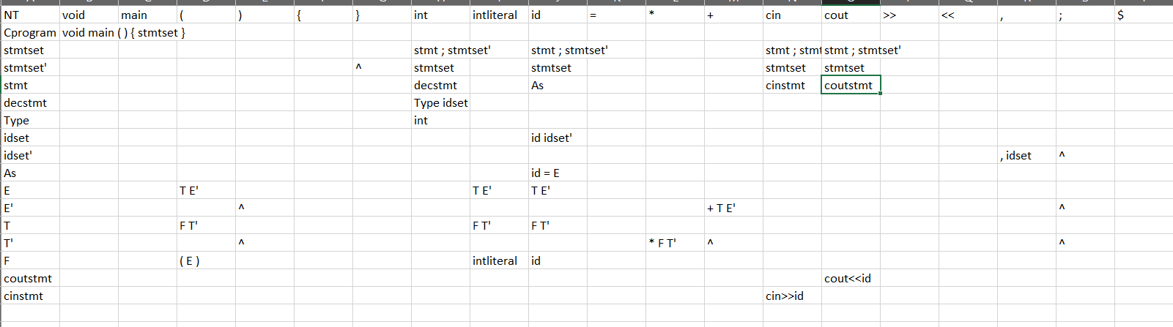

**Note:** You also see Parse Table in **“Parse Table.xlsx”** file .

**9) Parser Software using LL(1) approach ( it will print parse tree in the form of productions)**

**See Mini C Program folder run it**

**Note:** To run Project. you need to install some libraries

Libraries:

1) **pandas**

2) **xlrd**

3) **openpyxl**